**Kol simcha torah gazette**

**For parshas shemos 5784**

Volume 8 Issue 17 (Whole #375) 25 Teveth 5784/ January 6, 2023

**Printed L’illuy nishmas Nechama bas R’ Noach, a”h**

For a free subscription, please forward your request to [***keren18@juno.com***](mailto:keren18@juno.com)

***Past emails can be found on the website ShabbosStories.com under Brooklyn Torah Gazette***

**Antisemites Thrive When Jews are Embarrassed**

**About their Judaism**

**By Rabbi Efrem Goldberg**

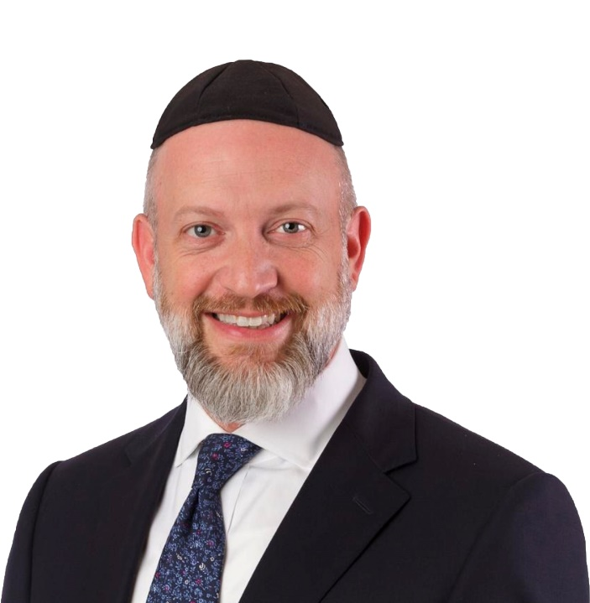

**Rabbi Efrem Goldberg**

Bret Stephens, the Pulitzer Prize-winning New York Times columnist, recently spoke at the Boca Raton Synagogue. In his talk, he referenced his recent [column](https://www.nytimes.com/2023/11/07/opinion/us-jewish-israel-sept-11.html), “For America’s Jews, Every Day Must Be Oct. 8.”

He opens:

There used to be a sign (which, for all I know, is still there) somewhere in the C.I.A.’s headquarters that read, “Every day is Sept. 12.” It was placed there to remind the agency’s staffers that what they felt right after the attacks of Sept. 11, 2001 — the sense of outrage and purpose, of favoring initiative over caution, of taking nothing for granted — had to be the mind-set with which they arrived to work every day.

**Every Day is Oct. 8th**

There ought to be a similar sign in every Jewish organization, synagogue and day school, and on the desks of anyone — Jewish or not — for whom the security and well-being of the Jews is a sacred calling: “Every day is Oct. 8.”

Stephens goes on to share several important and insightful takeaways of how we must forever be different since the horrific and barbaric pogroms, the likes of which we haven’t seen since the Holocaust. One of the key ones: “On Oct. 8, Jews woke up to discover who our friends are not.” Stephens continues to enumerate the “friends,” institutions of “prestige” and movements that abandoned us, betrayed us, and with whom we should no longer feel aligned or seek the approval of.

He concludes: “More than 3,800 years of Jewish history keeps yielding the same bracing lesson: In the long run, we’re alone. What can Oct. 8 Jews do? We can stop being embarrassed, equivocal or defensive about Zionism, which is, after all, one of the world’s most successful movements of national liberation… Jewish America abounds with dreamers and entrepreneurs who took crazy risks in their careers to find value and create things that never existed before. It’s time they apply the same talent and energy to creating new institutions that hew to genuinely liberal values, where Jews need never be afraid. In time, the rest of America may follow.”

**A Different Change without Which We**

**Cannot Hope to Defeat our Enemies**

Bret Stephens is a proud Jew and supporter of Israel, a brilliant and insightful commentator. However, I believe there is more for the October 8th Jew, a different change without which we cannot hope to defeat our enemies, and without which we cannot survive or thrive.

The October 8th Jew must not only lean in to their unapologetic Zionism but must embrace, live, and promote unapologetic Judaism. The October 8th Jew must find his or her voice, not only the voice and vocabulary to lobby, advocate, rally and fight for the rights of the Jewish state and the Jewish people. The October 8th Jew must find his or her distinctly Jewish voice, a voice informed and inspired by authentic Jewish wisdom. We must raise our voices of prayer and voices of study, our voices of Jewish unity and our voices of Torah insight, justice and truth.

**When Jews are Silent**

When Jacob presents himself to his father Isaac to seize the blessings from his brother Esau, he disguises his hands but not his voice. Troubled by the incongruity, Isaac wonders aloud, “the voice is the voice of Jacob, but the hands feel like the hands of Esau.” Noting the anomaly, that the voice of Jacob is simply incompatible with the hands of Esau, the rabbinic sages conclude (Midrash, [Bereishit Rabba 63:20](https://www.sefaria.org/Bereshit_Rabbah.63.20?lang=he-en&utm_source=aish.com&utm_medium=sefaria_linker" \t "_blank)):

“The voice is the voice of Jacob” – when the voice of Jacob is found in the synagogues, the hands are not the hands of Esau; but if not, “the hands are the hands of Esau.”

Antisemites thrive when we are assimilated, apologetic, defensive, embarrassed, or afraid about our Jewish identity and Jewish values. When we lower the volume on our Jewish voices, they are empowered to raise their hands against us and pounce.

The October 8th Jew must confront these enemies, sometimes on the battlefield, other times at congressional hearings, other times in the courtroom. But the October 8th Jew must also confront himself and herself, confront their Jewish passion, Jewish pride, and Jewish practice.

**Go Pro**

In his short but powerful book, *The War of Art*, Steven Pressfield talks about resistance, the force that holds us back form fulfilling our dreams and potential. He describes the dangers and the methodology of resistance and ultimately offers a strategy for how to overcome it. He writes:

Aspiring artists defeated by Resistance share one trait. They all think like amateurs. They have not yet turned pro.

The moment an artist turns pro is as epochal as the birth of his first child. With one stroke, everything changes. I can state absolutely that the term of my life can be divided into two parts: before turning pro, and after.

To be clear: When I say professional, I don’t mean doctors and lawyers, those of “the professions.” I mean the Professional as an ideal. The professional in contract to the amateur. Considers the differences.

The amateur plays for fun. The professional plays for keeps. To the amateur, the game is his avocation. To the pro it’s his vocation. The amateur plays part-time, the professional full-time. The amateur is a weekend warrior. The professional is there seven days a week.

The word *amateur* comes from the Latin root meaning “to love.” The conventional interpretation is that the amateur pursues his calling out of love, while the pro does it for money. Not the way I see it. In my view, the amateur does not love the game enough. If he did, he would not pursue it as a sideline, distinct from his “real” vocation.

The professional loves it so much, he dedicates his life to it. He commits full-time. That’s what I mean when I say turning pro. Resistance hates it when we turn pro.

Yes, the October 8th Jew must know who are not among our friends. As Bret Stephens convincingly argues, the October 8th Jew must be ready to build our own institutions that conform to our values.

But most importantly, the October 8th Jew must be ready to take their Judaism pro. From the observant to the unaffiliated, we cannot continue with our Judaism as usual, we cannot be amateurs with a casual attitude, lukewarm Jewish practices, impassive Jewish experiences and lives. Our Judaism must not be observed only on the weekends and holidays but must be there seven days a week. Our study and prayers must not be avocations but vocations. We must love our Judaism, the Torah and G-d so much we are ready to dedicate our lives.

On billboards, bumper stickers, and the sides of busses all over Israel is the motto – *Am ha’netzach y’nateiach*, the people of eternity will prevail. If we want to prevail, we must ensure that the October 8th Jew is practicing a Judaism of eternity.

*Reprinted from the current website of aish.com*

**And These are the Names of the Children of Israel (Ex. 1:1)**

One of the merits the Jewish people had to be redeemed from Egypt was that they did not change their Jewish names: Jews named Reuven and Shimon went down to Egypt, and Jews named Reuven and Shimon went up from there. They did not call Yehuda "Royfa"; Reuven "Loyliani"; Yosef "Loystus" or Binyamin "Alexandri." *(Midrash Raba)*

*And she called his name Moses (Moshe) and she said: Because I drew him out of the water* (Ex. 2:10)

Moses' name, Moshe, is in the present tense because it refers to an ongoing process: In every generation there is one "Moses" whose function is to pull Jews out of the depths of the "sea," lifting and elevating them from both spiritual and physical "mud." For "the reflection of Moses exists in each and every generation." *(Netivot Noach)*

*Reprinted from the Parshat Shemos 5761/2001 edition of L’Chaim.*

**Rav Miller on How to Deal**

**with the Problem of Feeling Rejected by Others**

**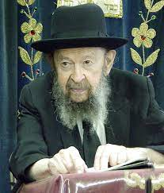**

**QUESTION:** What is the Torah perspective of how to deal with the problem of feeling rejected by others?

**ANSWER:** Now, rejection is a word that’s taken from modern psychology. Of course, people don’t want to feel rejected, but the very first thing for us to learn is that there’s only one criterion of right and wrong and that is the Toras Hashem. What people say is not important at all. It’s only what Hakodosh Boruch Hu thinks of you that matters.

However, we should take the da’as habriyos, the opinion of others, as an indication of something that might not be so good with us. If people have some reason to reject us, it could very well be that there’s something in us that deserves to be repaired, remedied. And we should learn from that and we should try to find out what’s wrong with us.

But suppose it’s not wrong in us; suppose it’s wrong with them – suppose they reject you because you’re too frum; then you reject them – that’s all. Why should you worry any longer? ינחלו חכמים „כבו – Those who are chachomim, they deserve kavod and the fact that fools won’t honor you it’s only because they don’t know whom to honor.

The fools honor the entertainment artists, they honor the baseball players; so let them honor. They’re fools. But you know what really deserves honor, so rejection from people like that is a word that means nothing. Unless chas v’shalom the ziknei ha’eidah reject you. That you have to worry about!

Does the rav of your shul reject you? Does the rebbe of your yeshiva reject you? That’s a big problem. Oh yes! Reb Yisroel Salanter said that the opinion of the ziknei ha’eidah, of the ziknei ha’ir, that’s the da’as Hashem.

If you want to know beforehand how you will be judged in Olam Habo, the way the ziknei ha’ir think of you, that’s how you’ll be judged in Olam Habo. That’s important! But the fact that this person or that person rejects you is meaningless. What do the chachmei haTorah think of you? You don’t know? Find out from those who are closest to you, what they think.

What does your rav think about you? Now, he may welcome you with a glad hand and make you feel that you’re important, but the question is, what does he actually think of you? Try to find out! And if you ever hear a word of criticism from him, you should take it seriously. That’s the rejection that means something.

*Reprinted from the Shemos 5783 email of Toras Avigdor.*

*\*\*\*\*\*\*\*\*\*\*\*\*\*\*\*\*\*\*\*\*\*\*\*\*\*\*\*\*\*\*\*\*\*\*\*\*\*\*\*\*\*\*\*\*\*\*\*\*\*\*\*\*\*\*\*\*\*\*\*\*\*\*\*\*\*\**

*Send, I beseech You, by the hand of him whom You will send* (Ex. 4:13)

There are some commandments in the Torah that cannot be done intentionally, such as the mitzva of the forgotten sheaf (which must be left for the poor). Being a leader is in this category, for "Whoever pursues honor, honor flees from him." Only a person who does not wish to lead is worthy of doing so. Thus it was not until Moses declined being the leader of the Jews that he merited the position. *(Prayer Book with Chasidic Interpretation)*

*And Pharaoh said...I do not know G-d [the Tetragrammaton], nor will I let Israel* go (Ex. 5:2)

The Tetragrammaton, or four-letter, ineffable Name of G-d, refers to the level of G-dliness that transcends nature, whereas "Elokim" refers to G-dliness as it is enclothed in nature. (The numerical equivalent of the word "Elokim" is the same as "hateva" - nature.) When Pharaoh said he did not know G-d, he meant that G-d's transcendental aspect has no connection to the physical world. In truth, however, G-d's ineffable Name illuminates equally in all worlds, which Pharaoh only came to realize after a series of miracles: "And the Egyptians shall know that I am G-d." *(Torah Ohr)*

*Reprinted from the Parshat Shemos 5761/2001 edition of L’Chaim.*

**Why Moses was Deeply Concerned About the Sin of Those Jews**

**Who Spoke Lashon Hora**

**From the Teachings of the Lubavitcher Rebbe**

**Rabbi Menachem Mendel Schneerson, Zt”l**

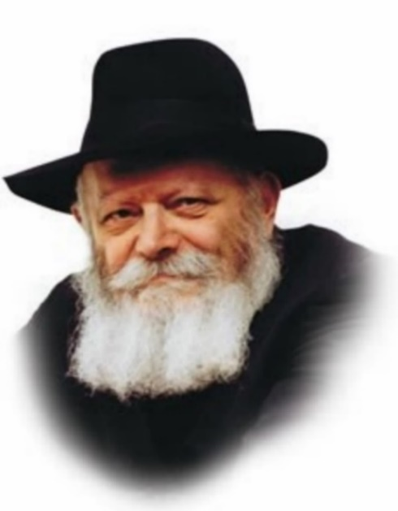

In this week's Torah portion, Shemot, we read that Moses "saw an Egyptian man smiting a Hebrew man...and he smote the Egyptian." The next day Moses went out and saw two Jewish men fighting. "He said to the wicked one, 'Why are you striking your fellow?' " To which the man answered, "Do you intend to kill me as you killed the Egyptian?"

The two Jews then went to Pharaoh and informed on Moses. "And Moses was afraid, and he said, 'Surely this thing is known.' "

**Moses was Concerned Also for**

**the Future of the Jewish People**

The Midrash explains that Moses was afraid not only for his own safety but for the future of the Jewish people. Till then, Moses had not understood what the Jews could possibly have done to justify being enslaved. But when he saw that there were Jews who engaged in gossip and slander (lashon hara), he worried that they might not be worthy of being redeemed.

At first glance, Moses' concern seems surprising. We know that during the Egyptian exile there were some Jews who descended to the level of idol worship, yet even this sin wasn't enough to prevent them from being redeemed. How could the sin of lashon hara be worse than idolatry, to the point that it justified the Jews' continued enslavement?

**“A Nation that Knows G-d”**

According to Maimonides, the Jewish people inherited their intrinsic faith in G-d from the Patriarchs, after which they became "a nation that knows G-d." However, "As Israel's sojourn in Egypt lengthened they regressed and learned from [the Egyptians'] deeds, and they began to worship the stars." Nonetheless, "G-d chose Israel as His inheritance, and crowned them with the commandments."

In other words, before the Exodus from Egypt the Jewish people were defined by their deeds: Jews were "a nation that knows G-d." This definition could no longer be applied when the Jews went into exile and worshipped idols. Nonetheless, it was precisely then that G-d chose them as a nation.

G-d did not choose the Jewish people because of their good deeds or superior qualities. His choice completely transcended all reason. That some Jews worshipped idols was therefore not a hindrance to their redemption.

**Dissension and Infighting Among Jews**

**Threatens our Very Existence as a Nation**

However, when Moses saw that there were Jewish gossipmongers, he became very frightened. Dissention and infighting among Jews threatens their very existence as a nation. Because G-d chose the Jews as a single, united entity, Moses worried that internal strife would cause them to lose that quality, and nullify their merit to be redeemed.

As it turned out, the difficulties and suffering of the exile drew the Jews together, and their renewed sense of unity made them worthy of being chosen by G-d. The Children of Israel were thus transformed into "a people forever," whose identity can never be lost among the nations.

*Reprinted from the Parshat Shemos 5761/2001 edition of L’Chaim. Adapted from Volume 31 of Likutei Sichot.*

**Rabbi Berel Wein on**

**Parshat Shemot 5784**

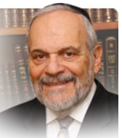

It should be obvious to all that Moshe is a very unlikely choice to head the Jewish people, to redeem them from Egyptian bondage, and to bring the Torah down from Heaven to the Jewish people and eventually to all of humankind. It is also clear that Moshe would not be the likely one to guide them through the vicissitudes of war, thirst and forty years sojourn in the desert of Sinai.

Rambam writes that Moshe was of short temper. The Torah records for us that he was raised in the palace of the Egyptian Pharaoh. He kills an Egyptian and covers up his deed. He is a shepherd for a pagan priest of Midyan and marries one of his daughters. He is separated from his people for sixty years before returning to them and proclaiming himself as their leader. Not really too impressive a resume for the greatest of all humans and of the Jewish people! But there it is for all to see and study. So, what is the message that the Torah is sending to us with this narrative?

Who needs to know of his previous life before becoming the Moshe we revere? After all, the Torah does not explicitly tell us about the youth experiences of Noach, Avraham and other great men of Israel and the world. So, why all the detail – much of it not too pleasant – about the early life of Moshe? The question almost begs itself of any student of Torah. The Torah is always concise and chary of words, so this concentration of facts and stories about Moshe’s early life is somewhat puzzling.

What is clear from biblical narrative and Jewish and world history generally is that Heaven does not play by our rules nor does it conduct itself by our preconceived norms and notions. We never would have chosen David as our king, Amos as our prophet or Esther as our savior from destruction. Jewish history in a great measure has been formed by unlikely heroes, unexpected champions and surprising personalities.

It is almost as if Heaven wishes to mock our pretensions and upset our conventional wisdom. Oftentimes it is our stubborn nature, our haughtiness to think that we are always privy to G-d’s plans and methods that has led us to stray far from truth and reality. The greatness of the generation that left Egypt was that it not only believed in the G-d of Israel but believed in His servant Moshe as well.

Throughout his career as leader of Israel, according to Midrash, the rebels would always hold Moshe’s past against him. They could not come to terms with Moshe as being their leader for he did not fit the paradigm that they had constructed for themselves. Eventually this disbelief in Moshe translated itself into a disbelief in G-d as well and doomed that generation to perish in the desert of Sinai. G-d’s plans, actions and choices, so to speak, are inscrutable. The prophet taught us that G-d stated: “For My thoughts are not your thoughts and My ways are not your ways.” Moshe’s life story is a striking example of this truism.

*Reprinted from the current website of rabbiwein.com*

\*\*\*\*\*\*\*\*\*\*\*\*\*\*\*\*\*\*\*\*\*\*\*\*\*\*\*\*\*\*\*\*\*\*\*\*\*\*\*\*\*\*\*\*\*\*\*\*\*\*\*\*\*\*\*\*\*\*\*\*\*\*\*\*\*\*

“*Hashem said to him, ‘What is that in your hand?’ and he said, ‘A Mateh / staff’*.” (4:2) R’ Michel Twerski (rabbi and Chassidic Rebbe in Milwaukee, Wisconsin) interprets allegorically: Hashem asked Moshe, “What is in your hand,” i.e., what do you think is really in your control? Moshe answered: “Only the Mateh.” The word “Mateh” shares a root with the verb, “to turn.” There is so much that is not in man’s control. What is in his control is the way he “turns,” i.e., his reactions to the events he experiences. (Yir’am Ha’yam: Bereishis)

*And the people believed and they heard that Hashem remembered the children of Israel*. (4:31) The order is backwards. The Pasuk should say that they heard that Hashem remembered Bnai Yisroel and they believed. When Bnai Yisroel believed that the redemption from Egypt will come only through Hashem, then and only then does Hashem remember Bnai Yisroel and the redemption will come. And so, to the the coming redemption will only come when we have the belief that it can only come from Hashem. (Taam Vodaas)

*Reprinted from this week’s email of R’ Yedidye Hirtenfeld’s whY I Matter parsha sheet of the Young Israel of Midwood in Brooklyn, NY.*

**Kidney Donation**

**By Rabbi Hillel Raskin**

****

**Rabbi Hillel Raskin**

**QUESTION:** Am I allowed or perhaps obligated to donate a kidney?

**REPLY:** The Torah says, “Lo saamod al dam rei’echa,” do not stand idly by your friend’s blood. Thus, one is obligated to invest effort, money, and discomfort (e.g., donating blood) to save the life of a fellow Jew.

But what about putting one’s own life at risk for this cause?

The Talmud Yerushalmi writes that one must put oneself in danger to save another Yid. The Rambam rules that one must do “whatever one can” to save a life, and the Hagahos Maimonis explains that he must even endanger himself.

Yet, most Rishonim don’t accept this Yerushalmi as halacha, and some go so far as calling one who does so a “chossid shoteh,” a foolish pious.

While the Beis Yosef quotes the Yerushalmi in his commentary on the Tur, he omits it in his Shulchan Aruch, implying that one should not endanger oneself to save someone else. Likewise, the Alter Rebbe writes that it is forbidden to endanger oneself even to save a friend from definite death.

**What about donating a kidney?**

Years ago, there was a significant risk to kidney donors. Therefore, eminent poskim like the Minchas Yitzchok and Tzitz Eliezer prohibited taking this risk.

However, as medicine developed, the risks of kidney donation has decreased and apply to less than 1% of donors. Recent poskim therefore note that it is no longer categorized as a common risk, or even a safek, probable risk.

While there is still a small risk, the Radvaz writes that one is allowed to place oneself at a minor risk to save his friend from a definite danger.

Still, poskim rule that there is no obligation to donate one’s kidney due to the degree of risk that still exists and potential complications down the line.

Yet, it is midas Chassidus and a great mitzvah to save another life in such a manner, and he has great merit in this world and the next.

*Reprinted from the Parshat Vayechi 5784 edition of The Weekly Farbrengen. Rabbi Raskin is Rov of Anash in Petach Tikva, Israel.*

**What’s the Jewish View on Meds for Weight Loss?**

**By Rabbi** [**Yehuda Shurpin**](https://www.chabad.org/search/keyword_cdo/kid/15169/jewish/Shurpin-Yehuda.htm)



***Art by***[***Sefira Lightstone***](https://www.chabad.org/3159160)

**Question:** Have you heard about the growing trend of using medications for easy weight loss? I'm curious about the Torah's viewpoint on this.

**Reply:** Absolutely, this issue has caught a lot of attention lately. These medications, available in injection or pill form, are becoming increasingly popular for their reported ease in helping people lose weight.

If your doctor were to prescribe these (or any) medications, it’s a mitzvah to take care of your health and listen to your doctor.

But is it okay to use such medications to enhance your appearance when it's not a medical necessity?

From a Jewish perspective, our bodies are entrusted to us by G‑d. They are not our own to do with as we please, but rather tools loaned to us to fulfill our mission in this world—a mission that requires a healthy body. We're thus obligated to take care of our health and avoid unnecessary risks.[1](javascript:doFootnote('1a6230021');)

Being fit and being healthy are not always synonymous. Many medications, including Ozempic, can have potential side effects, some of which might be severe and even fatal.

This places such medications in a category similar to cosmetic surgery. As mentioned above, our bodies are on loan, so “wounding” ourselves through any type of elective surgery may be problematic.

**The Woman Who Wanted Plastic Surgery to Find a Husband**

In 1964, several leading rabbis were consulted regarding the case of a woman who was considering plastic surgery to improve her chances of finding a suitable husband.

Some rabbis argued that this was an exception to the prohibition against self-wounding, as the purpose of the surgery was to alleviate severe emotional pain. They added that modern advancements minimize surgical risks, deeming it not life-threatening.[2](javascript:doFootnote('2a6230021');)

Others, however, firmly forbade cosmetic surgery, asserting that although the [Torah](https://www.chabad.org/library/article_cdo/aid/1426382/jewish/Torah.htm) directs us to seek medical help, this does not apply to purely cosmetic ailments.[3](javascript:doFootnote('3a6230021');)

This nuanced view suggests that one should carefully weigh the risks and benefits with a medical professional (and Rabbi if necessary) before deciding to take weight loss pills purely for cosmetic reasons.

**Do These Pills Require One to Recite a Blessing**

If you do take these pills, do you say a blessing before ingesting them?

Ordinarily, blessings are only meant to be said on food, eaten for pleasure and/or sustenance.

But what about these pills? On the one hand, they’re medication, not food. On the other hand, they make you feel full and take away your desire to eat, just like a good, square meal does.

Since this matter isn't definitively resolved, it's advisable to take these pills during a meal or snack. When you say the blessing, keep in mind that it should cover your medication as well.[4](javascript:doFootnote('4a6230021');)

**FOOTNOTES**

[1.](https://www.chabad.org/library/article_cdo/aid/6230021/jewish/Whats-the-Jewish-View-on-Meds-for-Weight-Loss.htm" \l "footnoteRef1a6230021) See *Shulchan Aruch Harav, Choshen Mishpat, Nizkei Guf veNefesh*, 4.

[2.](https://www.chabad.org/library/article_cdo/aid/6230021/jewish/Whats-the-Jewish-View-on-Meds-for-Weight-Loss.htm" \l "footnoteRef2a6230021) See Igrot Moshe, Choshen Mishpat 2:66; Chelkat Yaakov 3:11 and Choshen Mishpat 31 (new edition).

[3.](https://www.chabad.org/library/article_cdo/aid/6230021/jewish/Whats-the-Jewish-View-on-Meds-for-Weight-Loss.htm" \l "footnoteRef3a6230021) See responsa Tzitz Eliezer 11:41; Minchat Yitzchak 1:28:2.

[4.](https://www.chabad.org/library/article_cdo/aid/6230021/jewish/Whats-the-Jewish-View-on-Meds-for-Weight-Loss.htm" \l "footnoteRef4a6230021) See Piskei Teshuvot 204, fn. 71.

*Reprinted from the current website of Chabad.org*

*\*\*\*\*\*\*\*\*\*\*\*\*\*\*\*\*\*\*\*\*\*\*\*\*\*\*\*\*\*\*\*\*\*\*\*\*\*\*\*\*\*\*\*\*\*\*\*\*\*\*\*\*\*\*\*\*\*\*\*\*\*\*\*\*\*\**

“The woman conceived and gave birth to a son. She saw that he was good and she hid him for three months.” (2:2) The Gemara (Sotah 12a) teaches: What does it mean that Yocheved saw that her baby –later named, Moshe–was “good”? It means the entire house filled with light. The Gemara states further: She saw that the Shechinah was with him. [Until here from the Gemara] Midrashim state that Haman was pleased when his lot fell on the month of Adar, for he knew that Moshe died in Adar. However, he did not know that Moshe also was born in Adar.

Why, asks, R’ Eliezer Dan Ralbag z”l (1832-1895; Yerushalayim), did Haman not know that Moshe was born in Adar? (It stands to reason that the same way that he had learned one fact about Moshe, he could have learned the second fact.) R’ Ralbag explains: Why did the house fill up with light when Moshe was born? And, what is the significance of the three months for which Yocheved hid Moshe?

The answer is that Moshe was born three months prematurely. The Gemara (Niddah 30b) states that as long as a baby is in the womb, a “candle” burns above his head. That “candle” is the light of the Shechinah that accompanies the baby as he learns Torah in the womb. When Moshe was born prematurely, his Neshamah complained to Hashem: “Why should I miss out on three more months of the Shechinah’s company?” Therefore, the Shechinah remained with him, and “the entire house filled with light.”

This continued for three months, until the day Moshe was due to have been born. (What was that date? Not coincidentally, it was 7 Sivan, the date on which the Torah later would be given.) This explains Haman’s mistake. Haman knew that Moshe was born on 7 Adar. However, Haman thought that the seventh of Sivan, the day when the light of the Shechinah departed from Moshe, counted as his birth date, just like for any other baby that is born. We know otherwise–i.e., that Moshe’s birthday is 7 Adar–because Moshe told us so (see Devarim 31:2 and Rashi z”l there). (Damesek Eliezer)

*Reprinted from this week’s email of R’ Yedidye Hirtenfeld’s whY I Matter parsha sheet of the Young Israel of Midwood in Brooklyn, NY.*